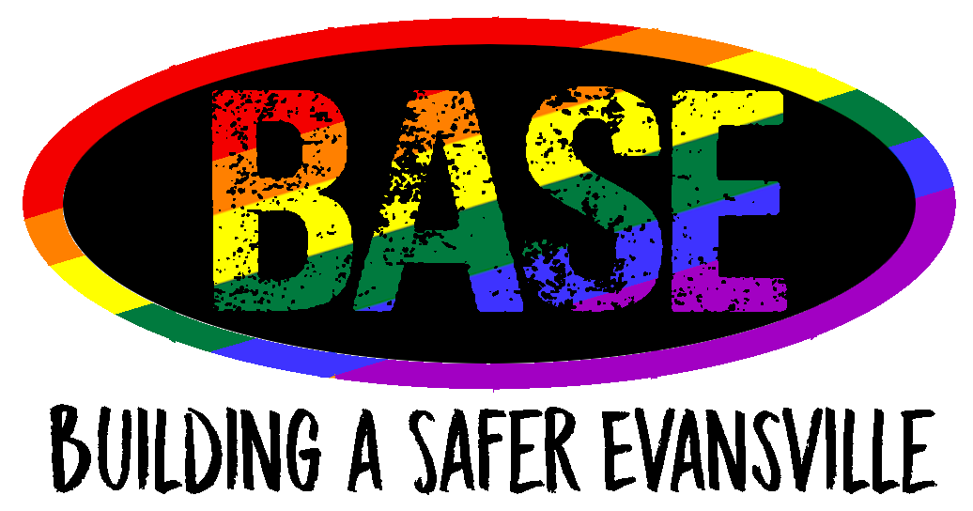

PRIDE DISC GOLF TOURNAMENT OFFICIAL RULES

Tournament Period - October 1st to October 31st at 11:59 PM
Location - Lake Leota Park - Disc Golf Course
Prize - receive One (1) set of Innova Starter Disc Golf discs with BASE logo
1. All entrants will follow game rules according found at the Disc Golf Association website or at the bottom of this webpage.
2. Entrants will use a Pride Disc Golf Tournament Official Scorecard to record their score and submit as an official entry. Scorecards can be found at Hole #1 of the Lake Leota Disc Golf Course or by downloading and printing the scorecard found at the bottom of this page. Limit 1 scorecard per entrant.
3. The tournament will be open from October 1st until October 31st at 11:59 PM. All entries must be received by October 31st at 11:59 PM in order to be counted.
4. To enter, a picture of the complete scorecard must be sent to the BASE Instagram @BASEvansville09 by October 31st at 11:59 PM. You will receive a message back from the account acknowledging your entry.
5. By entering into this tournament, you give BASE permission to share your name and completed scorecard on social media for promotion purposes related to this tournament. Weekly updates will be given to standings and current entries.
6. The top 5 scores will be entered into a drawing to determine the winner and that winner will be announced no later than November 2nd, 2020.
7. To be eligible to win, you must be 12 years of age with parent or guardian permission or 18 years of age. If you are under the age of 18 and are chosen as the winner, BASE will follow up with your parent or guardian before announcing you as the winner.

